 | 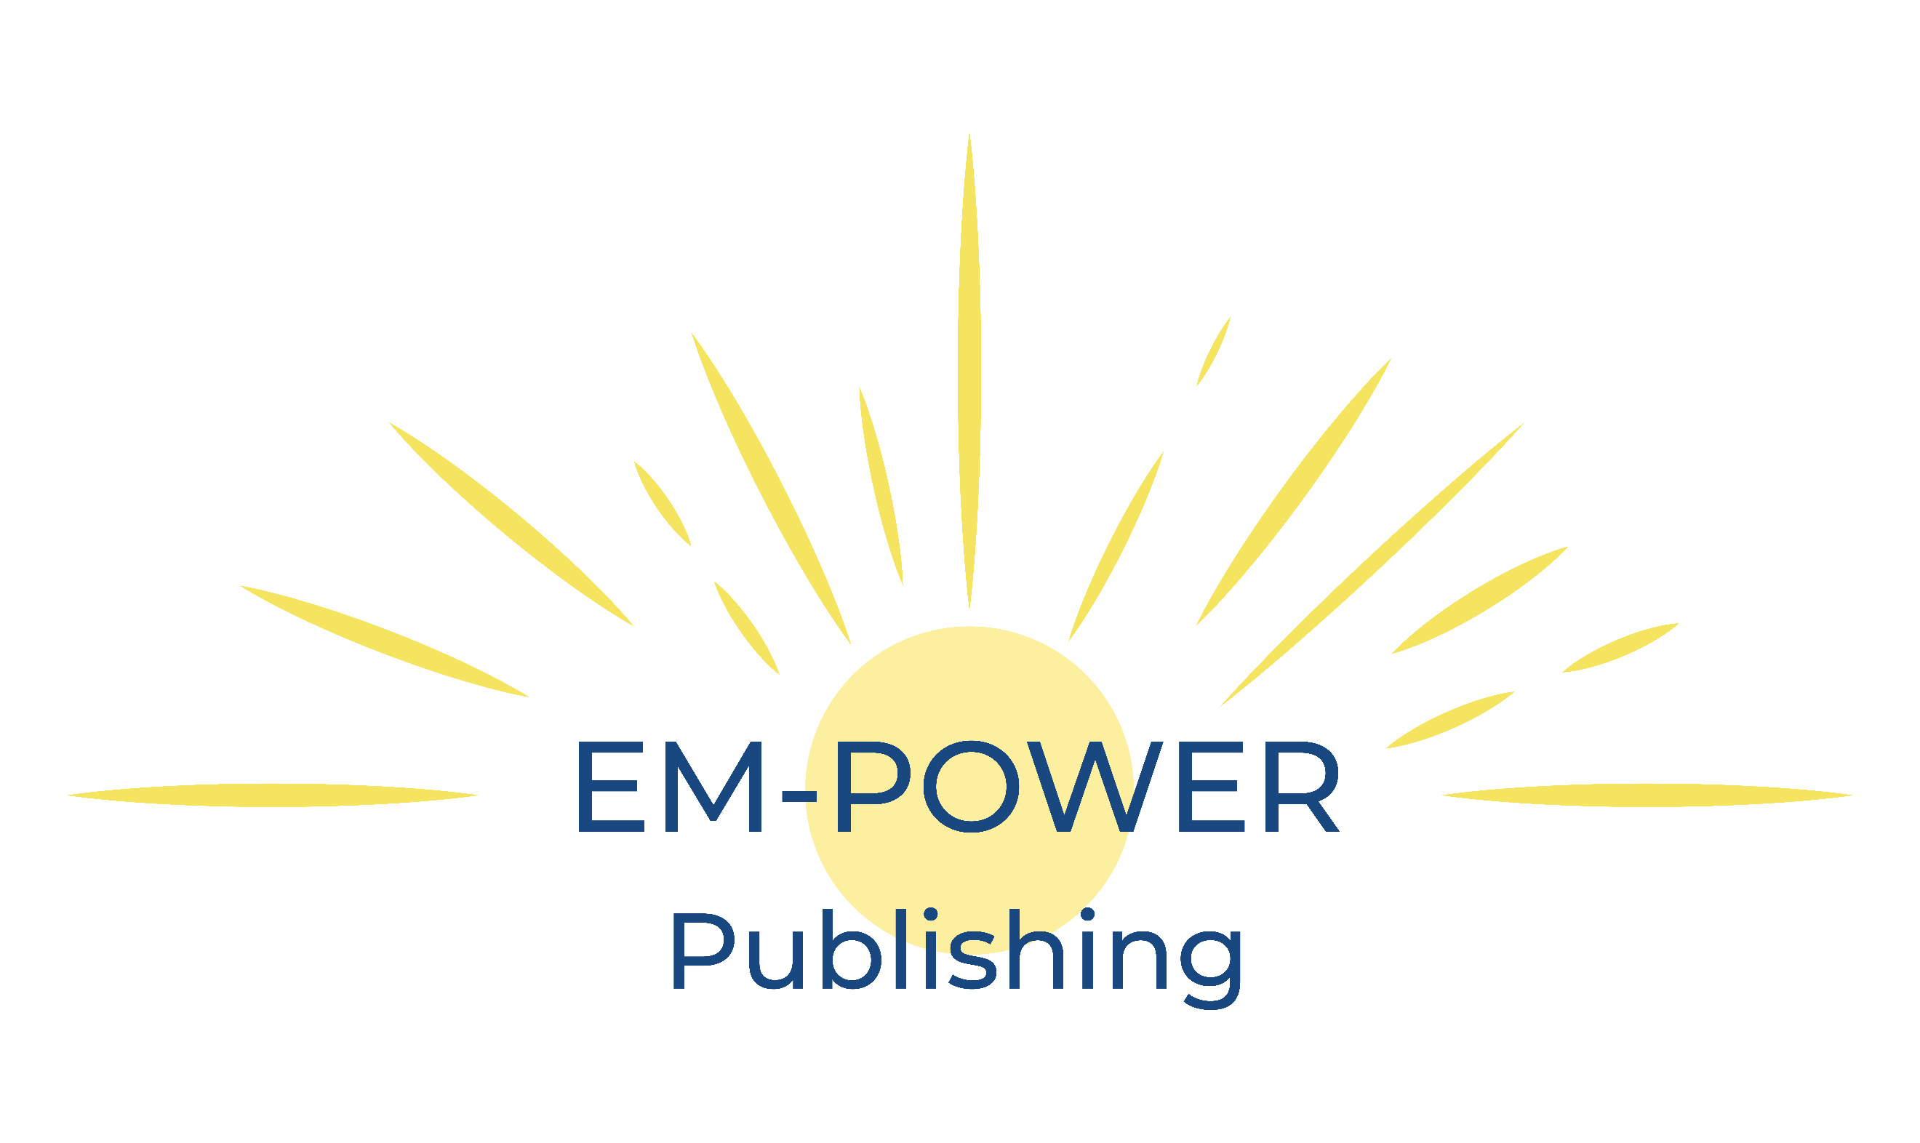 | Lisa Fontanella  EM-POWER Publishing  (207) 956-1786  Lisa@em-powerpublishing.com  www.EM-POWERPublishing.com

Lisa Fontanella

Lisa Fontanella is an award-winning published author, Reiki master, holistic practitioner and certified Life Coach. She loves writing and rocks and has used every opportunity to write. From stories, magazine and newspaper articles to newsletters and promotional materials, to published author. Her You Rock! Series includes the first of her chapter books Crystal’s Quest: An Adventure into the World of Gemstones plus My Thoughts for Today, A Guided Journal and Coloring Book.
A wannabe rockhound, Lisa loves learning about rocks, their properties and feeling their energy. What better way to blend two things she loves – write a children’s book about rocks!
Lisa’s fascination with rocks has taken on many forms, much like the rocks she holds so dear. She creates jewelry using gemstones, writes stories for children about the wonders of rocks, and gets so excited when she sees a type of rock she has never seen before.
Lisa lives in Virginia and loves being near the water whether it be the ocean, river, lake, pond, or puddle.

